**LAB#2:**

1. Create a web page named as E-Learning Lecture Tutorials web page should contain Video tag and audio tag (at least 3 videos and audio). Attached the output and the code.

**Task#1:**

* Index.html

|  |
| --- |
| **<!DOCTYPE html>**  **<html lang="en">**  **<head>**  **<meta charset="UTF-8">**  **<meta http-equiv="X-UA-Compatible" content="IE=edge">**  **<meta name="viewport" content="width=device-width, initial-scale=1.0">**  **<title>E-Learning Lecture Tutorials</title>**  **</head>**  **<body>**  **<h1>E-Learning Lecture Tutorials</h1>**  **<h2>Videos:</h2>**  **<video width="560" height="315" controls>**  **<source src="video1.mp4" type="video/mp4">**  **Your browser does not support the video tag.**  **</video>**  **<p>Video 1: Introduction to Programming</p>**  **<p>Video 2: Advanced Web Development</p>**  **<video width="560" height="315" controls>**  **<source src="video3.mp4" type="video/mp4">**  **Your browser does not support the video tag.**  **</video>**  **<p>Video 3: Data Structures and Algorithms</p>**  **<h2>Audios:</h2>**  **<audio controls>**  **<source src="audio1.mp3" type="audio/mpeg">**  **Your browser does not support the audio tag.**  **</audio>**  **<p>Audio 1: Lecture on Software Engineering</p>**  **<audio controls>**  **<source src="audio2.mp3" type="audio/mpeg">**  **Your browser does not support the audio tag.**  **</audio>**  **<p>Audio 2: Lecture on Database Management</p>**  **<audio controls>**  **<source src="audio3.mp3" type="audio/mpeg">**  **Your browser does not support the audio tag.**  **</audio>**  **<p>Audio 3: Lecture on Artificial Intelligence</p>**  **</body>**  **</html>** |

**Output:**

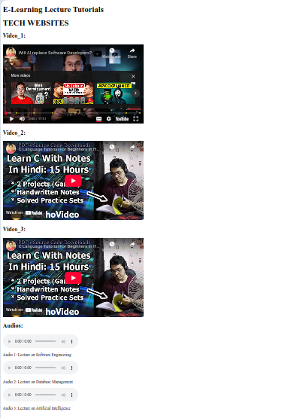

2. Create your Time Table. Attached the output and the code

**Task#2:**

* **Index.html**

|  |
| --- |
| **<!DOCTYPE html>**  **<html lang="en">**  **<head>**  **<meta charset="UTF-8">**  **<meta http-equiv="X-UA-Compatible" content="IE=edge">**  **<meta name="viewport" content="width=device-width, initial-scale=1.0">**  **<title>E-Learning Lecture</title>**  **</head>**  **<body>**  **<h1> TABLES OF 4<sup>th</sup>Semester:</h1>**  **<table border="2px solid black">**  **<tr>**  **<th>Period/Time</th>**  **<th>08:30 - 09:25</th>**  **<th>09:25 - 10:20</th>**  **<th>10:20 - 11:15</th>**  **<th>11:30 - 12:25</th>**  **<th>12:25 - 01:20</th>**  **<th>01:20 - 02:15</th>**  **<th>02:45 - 03:40</th>**  **<th>03:40 - 04:35</th>**  **<th>04:35 - 05:30</th>**  **</tr>**  **<tr>**  **<th>Monday</th>**  **<td colspan="3">Software Testing Technologies(P)<br> Bushra Aziz (BA)</td>**  **<td>Probability And Statistics<br> Rehan Ahmed Khan (RAK)</td>**  **<td></td>**  **<td>Software Testing Technologies<br> Bushra Aziz (BA)</td>**  **<td colspan="2">Software Operations And Maintenance<br> Shagufta Aftab (SA1)</td>**  **<td></td>**  **</tr>**  **<tr>**  **<th>Tuesday</th>**  **<td colspan="3">Mobile Application Development<br> Sidra Khatoon (SK)</td>**  **<td colspan="2">Operating Systems<br> Bushra Aziz (BA)</td>**  **<td></td>**  **<td colspan="3">Web Development Technologies<br> Bilal Iqbal (BI)</td>**  **</tr>**  **<tr>**  **<th>Wednesday</th>**  **<td colspan="3">Mobile Application Development(P)<br> Sidra Khatoon (SK)</td>**  **<td colspan="2">Operating Systems(P)<br> Bushra Aziz (BA)</td>**  **<td></td>**  **<td colspan="3">Software Operations And Maintenance(P)<br> Shagufta Aftab (SA1)</td>**  **</tr>**  **<tr>**  **<th>Thursday</th>**  **<td><br></br></td>**  **<td><br></br></td>**  **<td colspan="2">Probability And Statistics<br> Rehan Ahmed Khan (RAK)</td>**  **<td></td>**  **<td></td>**  **<td colspan="3">Web Development Technologies(P)<br> Bilal Iqbal (BI)</td>**  **</tr>**  **</table>**  **</body>**  **</html>** |

**Output:**

